

**GROUP ENERGY**

**2018**

***THIS MATERIAL BELONGS TO*** _________________________________________________________________________________

**Table of contents**

**SELF-STUDY - DEVELOPMENT**

* TIPS ON LEARNING

**GRAMMAR**

* PREPOSITIONS – SOME TIPS

**VERB TENSES**

* PRESENT PERFECT

**VOCABULARY**

* FUNCTIONS IN INTERNATIONAL BUSINESS

Source: ENGLISH VOCABULARY IN USE

By Stuart Redman

© Cambridge University Press

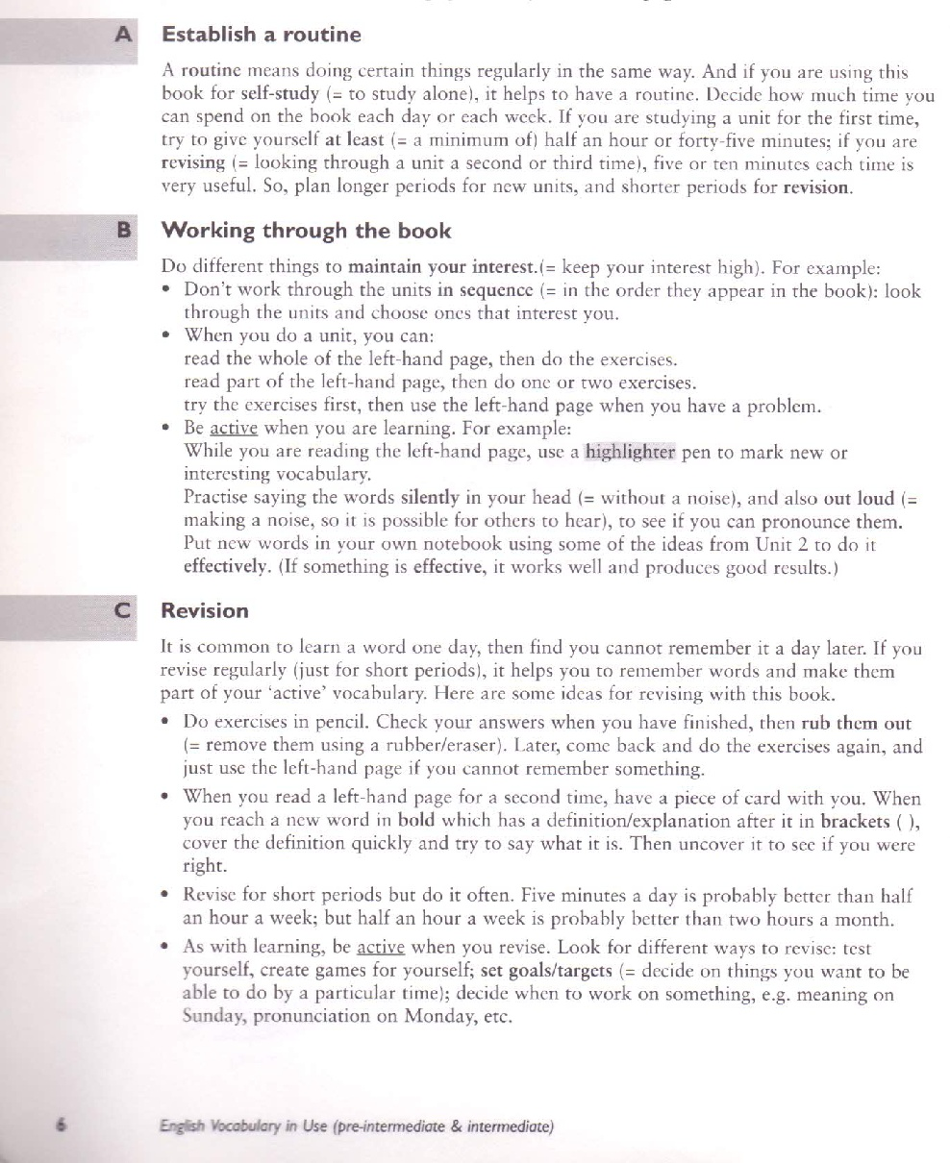

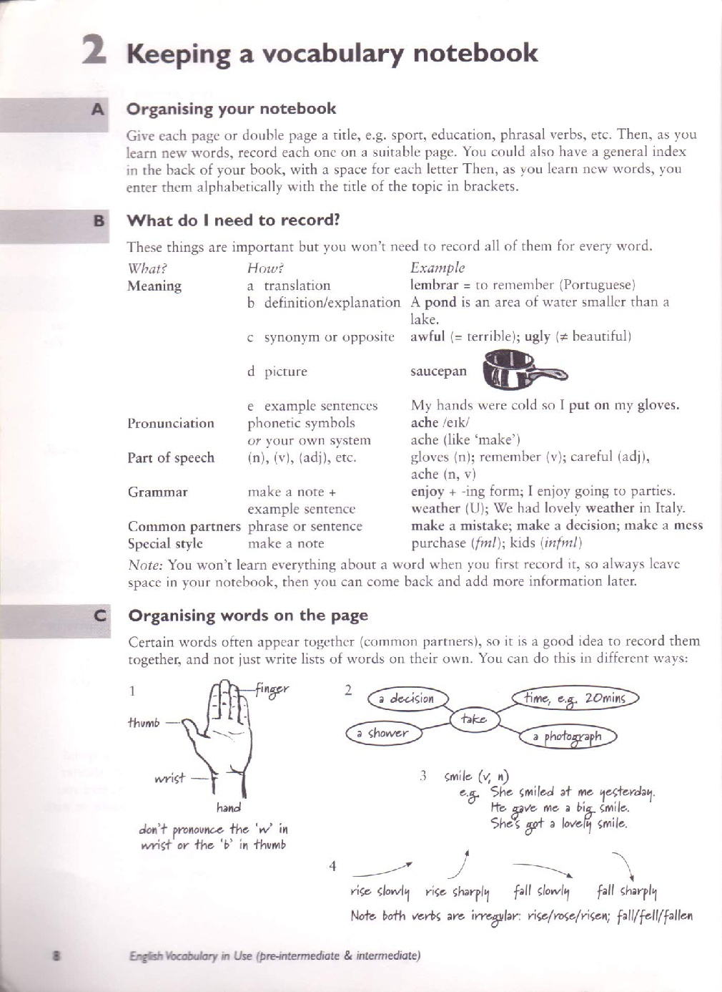

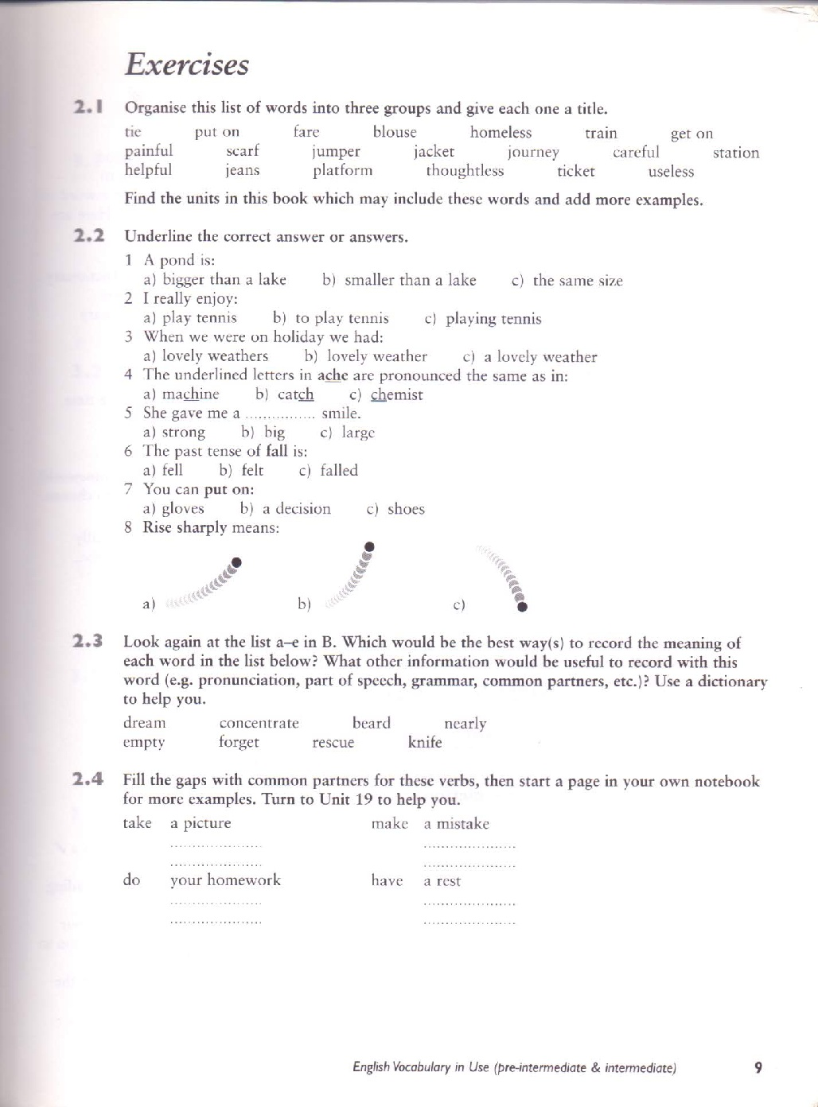

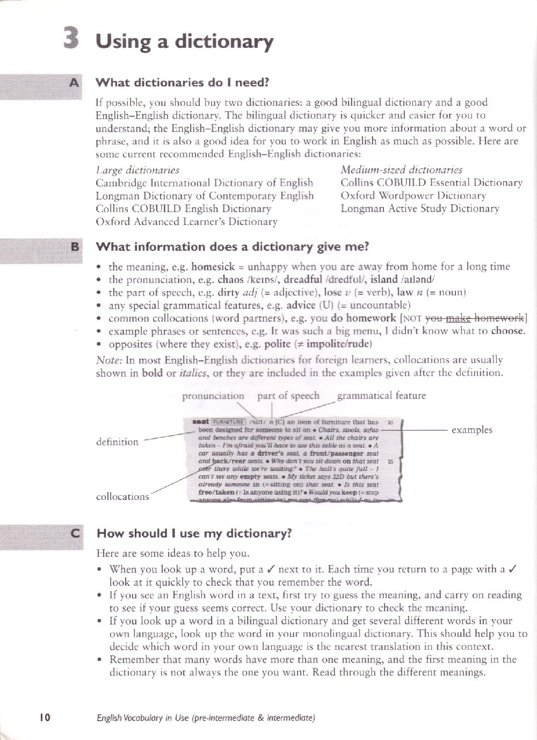

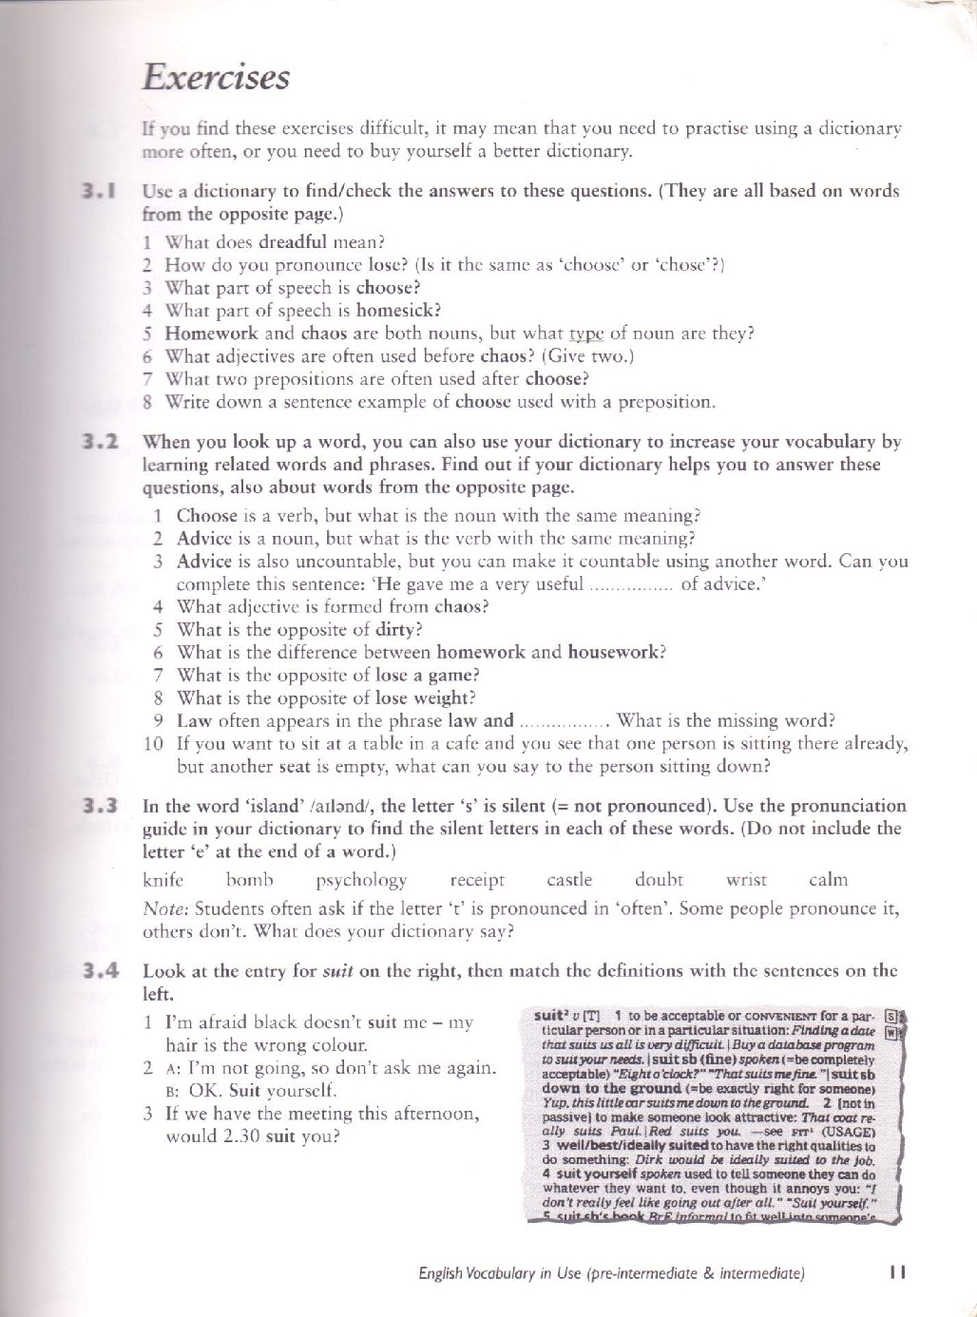

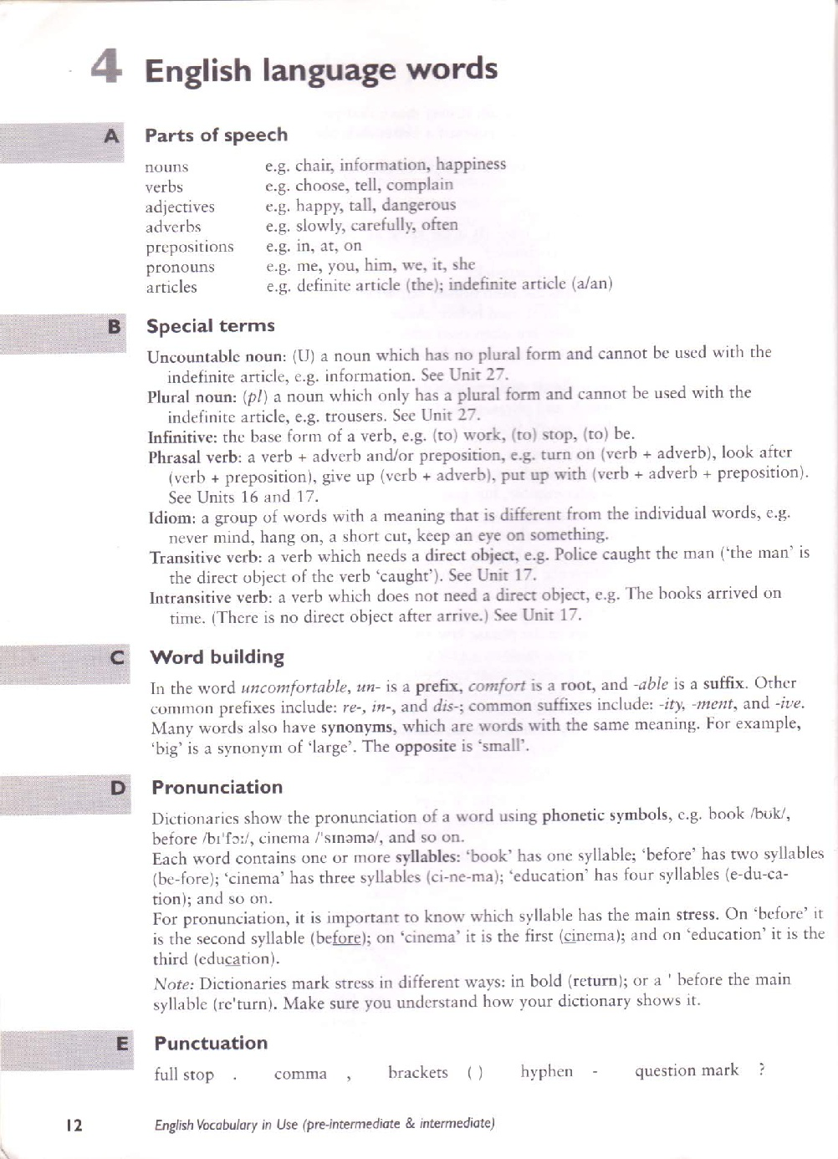

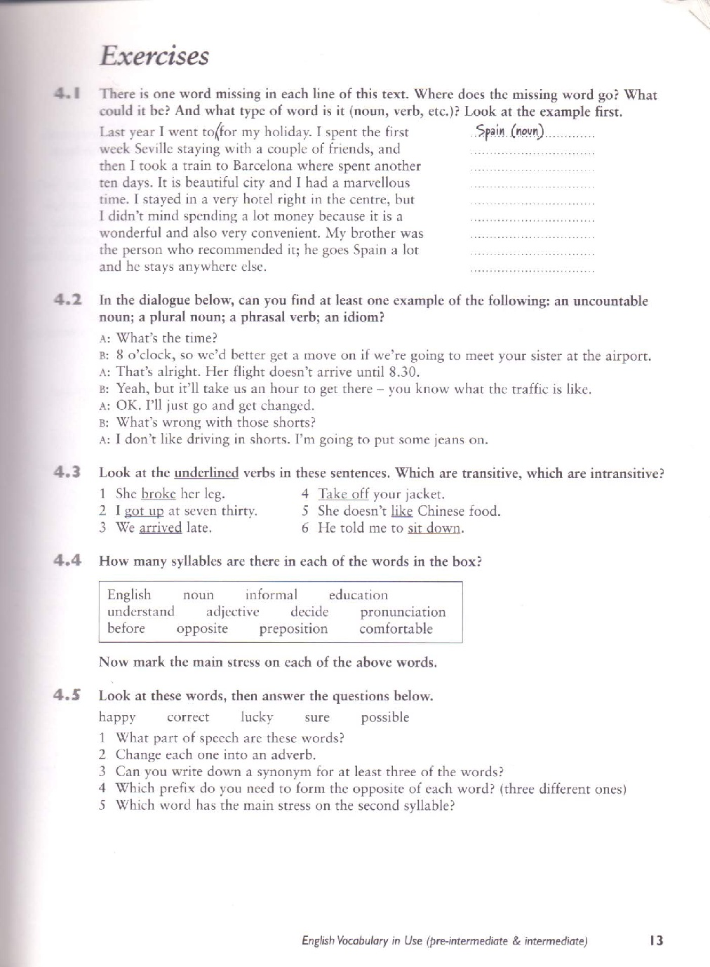

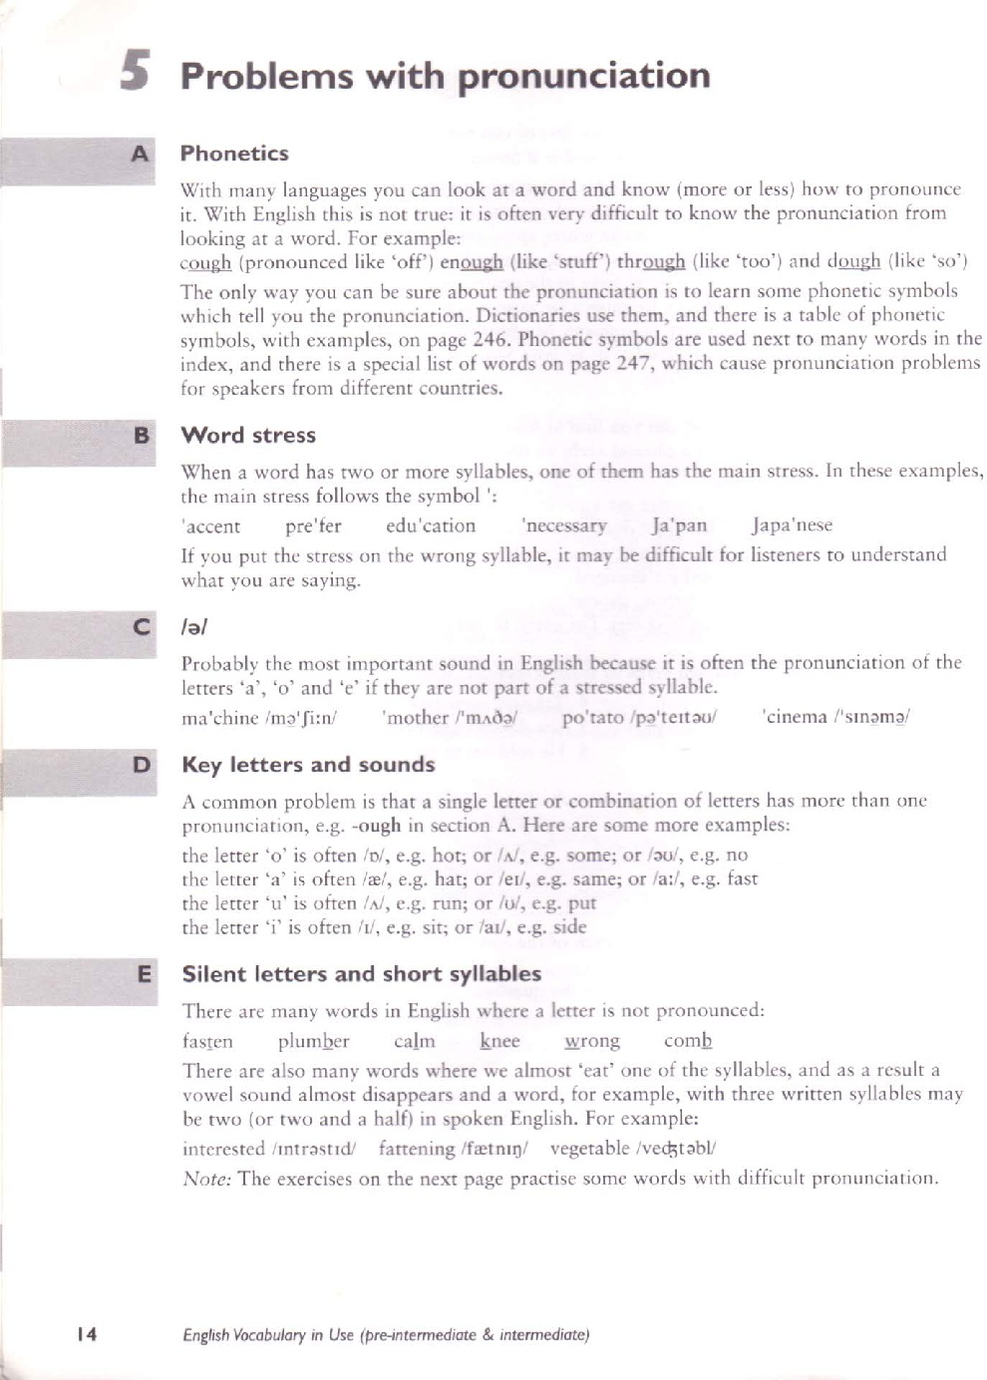

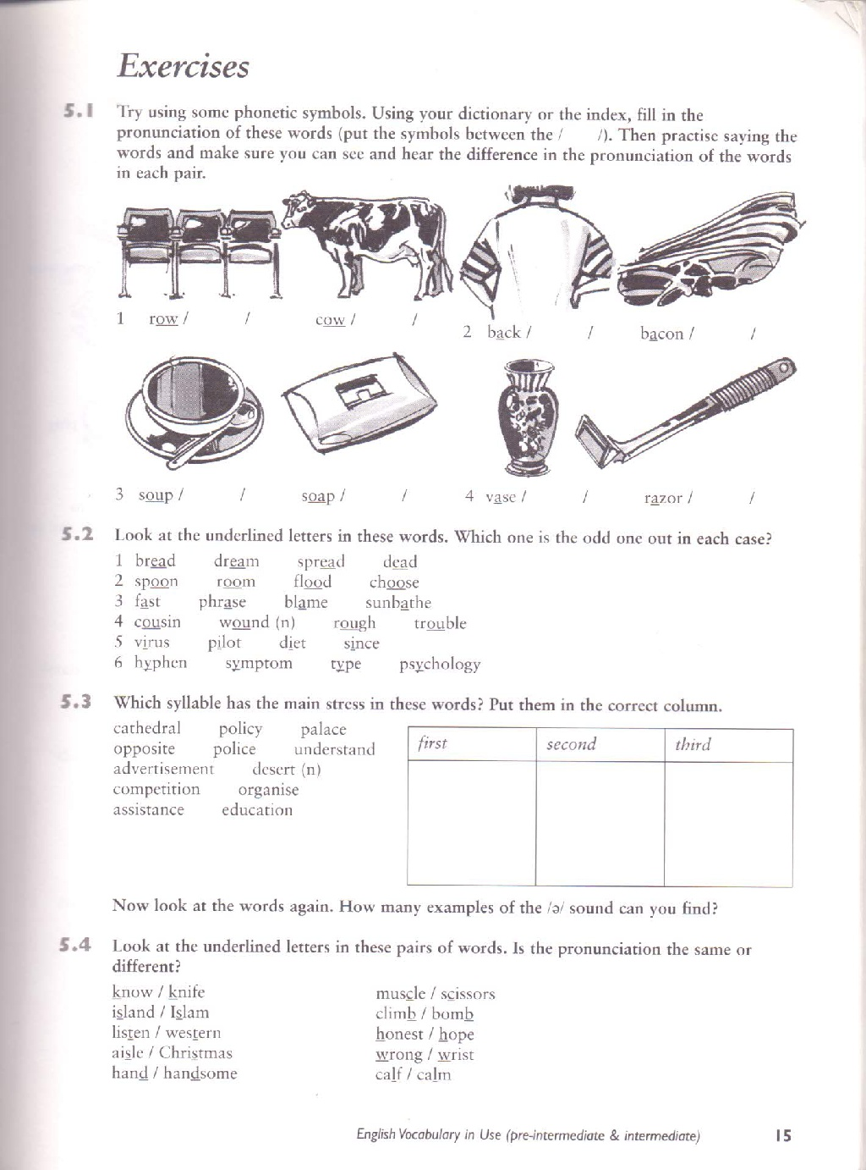

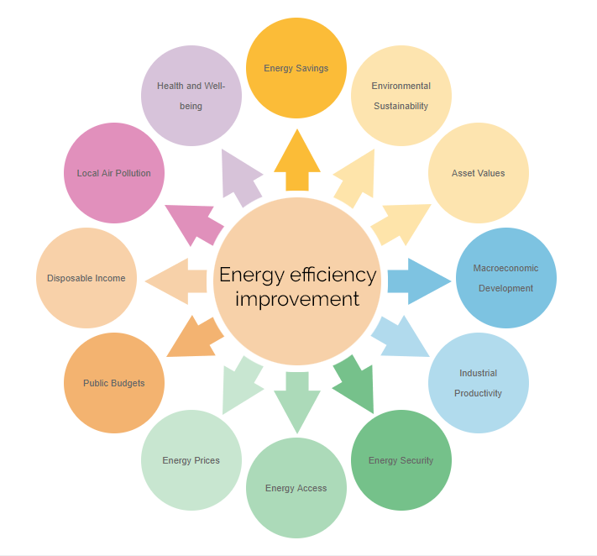

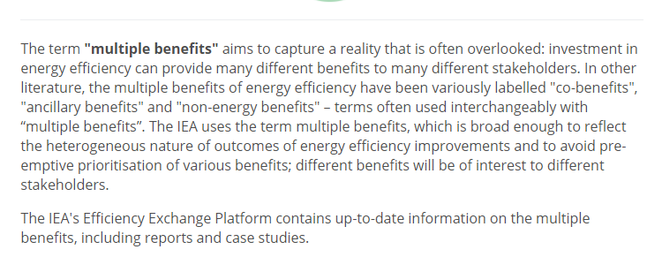



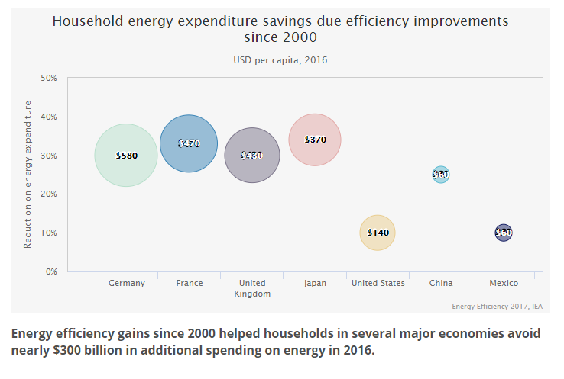

Some Tips on Prepositions

|  |  |
| --- | --- |
|  | *The objective of this material is to provide students with some tips on how to study prepositions. The tips will help minimize students’ chances of making mistakes. There are exceptions, mind you.* |

*Avoid translations!*

*Portuguese and English have different origins. There are some coincidences in terms of use of prepositions. However, there are many cases that may cause some confusion.*

*Focus on groups of words, not on prepositions*

*Remember this: words that belong to the same group USUALLY are followed by the same preposition.*

*Although the “rule” above does not solve all problems regarding prepositions (hey, there are exceptions…), it helps minimize chances of making mistakes.*

*If you memorize one example in each group of words - and exception (or exceptions) - it will be much easier than thinking about the possible meanings and uses of each preposition.*

*Remember that words that have opposite meanings also belong to the same group.*

*Two examples: AGREE and DISAGREE. Although one is the opposite of the other, both of them are followed by the same preposition!*

*Examples:*

* *She agrees with me*
* *She disagrees with me*

|  |  |
| --- | --- |
|  | ***Here are some groups of words:*** |

|  |  |  |
| --- | --- | --- |
|  | **“DAYS”**  Preposition: Usually *ON* | |
| * *ON Monday* * *ON Tuesday,* * *ON Wednesday,* * *ON Thursday,* * *ON Friday,* | | * *ON Saturday,* * *ON Sunday,* * *ON January 1st,* * *ON February 22nd,* * *ON the weekend* |

|  |  |  |
| --- | --- | --- |
|  | **“PARTS OF THE DAY”**  Preposition: Usually *IN* | |
| * *IN the morning* * *IN the afternoon* * *IN the evening* | | Exception: |
| • *AT night* |

|  |  |  |
| --- | --- | --- |
|  | **“TIME DIVISIONS”**  Preposition: Usually *IN* | |
| * *IN the first week, etc.* * *IN the second quarter, etc.* * *IN the first semester, etc.* * *IN years (in 2010, etc.)* * *IN the 21st century* | | * *IN seasons* * *IN millennium* * *IN months (in January, etc.)* |
| *Exceptions:*   * *Days (ON Monday, etc.)* * *Parts of the day (IN the morning, etc. and AT night)* * *Time (AT 2 o’clock, AT midnight, etc.)* | | |

|  |  |  |
| --- | --- | --- |
|  | **“STREETS”**  Preposition: Usually *ON* | |
| * *ON streets* * *ON roads* * *ON avenues* * *ON drives* * *ON lanes* | | * *ON boulevards* * *ON highways* * *ON freeways* * *ON blocks* |
| *Exception:*   * *Location on a street, road, avenue, etc.*   *e.g. AT 234 Washington Street* | | |

|  |  |  |
| --- | --- | --- |
|  | **“GEOGRAPHIC DIVISIONS”**  Preposition: Usually *IN* | |
| * *IN towns,* * *IN countries,* * *IN continents,* * *IN areas,* | | * *IN zones,* * *IN cardinal points (in the north, south, east, west, etc.)* |

|  |  |  |  |
| --- | --- | --- | --- |
|  | | **“COMMUNICATION AND MEDIA”**  Preposition: Usually *ON* | |
| * *ON the radio* * *ON TV* * *ON CD* * *ON DVD* * *ON billboards* | | | * *ON the internet* * *ON the intranet* * *ON the extranet* |
| *Exceptions:*  (printed media) | * *IN newspapers* * *IN magazines* * *IN books* | | |

|  |  |  |  |
| --- | --- | --- | --- |
|  | | **“VERBS OF MOVEMENT”**  Preposition: Usually *TO* | |
| * *Go TO,* * *Travel TO,* * *Drive TO,* * *Fly TO,* * *Navigate TO,* | | | * *Sail TO,* * *Walk TO,* * *Ride TO,* * *Swim TO, etc.* |
| *Exceptions:* | * *Go home* * *Go downtown* | | |

|  |  |  |
| --- | --- | --- |
|  | **“HOW?”**  Preposition: Usually *BY* | |
| * *How you do things?* * *How you go to places?* | | *The answers contain ‘BY’:*   * *By e-mail* * *By fax* * *By hand* * *By car, place, etc.* * *By saving money* * *By cutting expenses, etc.* |

|  |  |  |
| --- | --- | --- |
|  | **“SURFACES”**  Preposition: Usually *ON* | |
| * *ON the floor,* * *ON the ground,* * *ON the wall,* * *ON the ceiling,* * *ON the roof,* | | * *ON planets (ON Earth, ON Mars, On the Moon, etc.)* |

|  |  |  |  |
| --- | --- | --- | --- |
|  | **“MEANS OF TRANSPORTATION”**  Preposition: Usually *ON & OFF* | | |
| *You are ON or you get ON:*   * *ON the bus,* * *ON the subway,* * *On the train,* * *On the plane,* | | * *ON the ship* * *ON starships (e.g. on the Enterprise)* * *On motorcycles* * *On horses* | |
| *Notes:* | | | |
| *Position:* | | | |
| *Inside* | | | *Outside* |
| *You are ON the bus, etc.* | | | *You are OFF the bus, etc.* |
| *Movement:* | | | |
| *Outside => Inside* | | | *Inside =>Outside* |
| *You get ON the bus, etc.* | | | *You get OFF the bus, etc.* |
| ***Exceptions:*** | | | |
| ***IN cars***  ***IN taxis***  ***IN elevators*** | | | |
| *Notes:* | | | |
| *Position:* | | | |
| *Inside* | | | *Outside* |
| *You are IN the car*  *You are IN the taxi*  *You are IN the elevator* | | | *You are OUT OF the car*  *You are OUT OF the taxi*  *You are OUT OF the elevator* |
| *Movement:* | | | |
| *From Outside => Inside* | | | *From Inside =>Outside* |
| *You get IN the car*  *You get IN the taxi*  *You get IN the elevator* | | | *You get OUT OF the car*  *You get OUT OF the taxi*  *You get OUT OF the elevator* |



Now come up with your own groups of words!!

|  |  |  |  |
| --- | --- | --- | --- |
|  | **“ATTITUDE TOWARDS OTHER PEOPLE”**  Preposition: Usually *TO* | | |
| * *Good TO* * *Polite TO* | | * *Rude TO* * *Nice TO* | * *Impolite TO* * *Bad TO* * *Cruel TO, etc.* |

**Exercises:**

Note: click on the arrow on the right hand side of the box. The alternatives will be shown. Then select the one that completes the sentence correctly.

01. Where do you come  ?

02. My cousin lives                   Norway.

03. They are walking                   the bridge.

04. I don't like flying, so I went to Paris                   bus.

05. You can stay                   me tonight.

06. My birthday is                   29th February.

07. I'll see you                   Christmas.

08. Put the books                   the table, please.

09. I haven't seen you                   ages.

10. I like this house                   the river.

11. My parents got married                 2010.

12. The police station is                 the right.

13. We're going                 Italy for our holidays.

14. We borrowed the bikes                 our uncle.

15. There is a bridge                 the river.

16. I saw Chris                 the bus.

17. Be nice                 your brother.

18. Let's meet                 the afternoon, not                 night.

19. My friend lives                 the house                 the end of the street.

20. They are not                 home                 the moment.

21. Turn right                 the traffic lights.

22. She is not here, she is                 holiday.

23. A comes                 B in the alphabet.

24. The cat is sitting                 the wall.

25. Emily left school                 the age of 16.

26. I'll see you                 Monday morning.

27. Do not open the tin                 a knife!

28. This laptop belongs                 our teacher.

29. The film was very funny                 the end.

30. We've been here                 four days now.

31. Hamlet was written                 Shakespeare.

32. John is a student                 Oslo university.

33. The temperature was                 zero.

34. You have to write the paper                 hand.

35. We live                 the main road, so it is always very loud.

36. The trains are seldom                 time.

37. There were a lot of people                 our party.

38. Your room is                 the second floor.

39. Can you translate this from English                 French?

40.   August 1st we'll go                 Stratford.

41. My mum studied                   university.

42. There is a spider                   the corner of my room.

43. Death Valley is 56 meters                   sea level.

44. The train to London stopped                   the station.

45. Emily sits                   Susan and Greg.

46. There was an accident                   the crossroads.

47. Congratulations                   your new job!

48. Would you buy a coffee                   credit card?

49. What is behind the rise                   Wall Street?

50. This flight goes to Washington DC                   Charlotte.

I'm Peter and I live           Germany.           summer I like to travel           Italy, because           the weather and the people there. Last summer I took a plane           Munich to Rome.           the airport we went to our hotel           bus. We stopped           a small restaurant for a quick meal. The driver parked the bus           the restaurant. Nobody could find the bus and the driver, so we waited           the restaurant           one hour. The driver was walking           the small park           the restaurant which we did not know. So we were very angry           him. But my holidays were great. We sat  campfires and went dancing           the early mornings.

Source: [www.englisch-hilfen.de](http://www.englisch-hilfen.de)

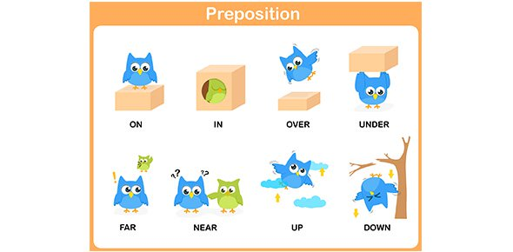

Source: How English Works, pages 151 -157

By Michael Swan and Catherine Walter © Oxford University Press

